SOFTWARE DESIGN DOCUMENT

FOR

ENHANCED COURSE FEEDBACK SYSTEM

Version 1.0

Tanayça Ünlütürk – Eda Kocaman

Table of Contents

1. Introduction 4

1.1 Purpose 4

1.2 Scope 4

1.3 Intended Audience 4

1.4 Glossary 4

1.5 References 4

2. Design Overview 4

2.1 Product Perspective 4

2.2 Technologies Used 4

2.3 System Architecture 5

2.4 System Operation 6

2.4.1 Activity Diagram 6

2.4.2 Use Case Diagram 7

3. UI Design 8

3.1 Sign Up Page 8

3.2 Log in Page 9

3.3 Feedback Request Form Page 10

3.4 Summarized Feedback List Page 11

3.5 View Feedback Page 15

3.6 Student Feedback Form Page 16

3.7 GPT Config Page 17

3.8 E-mail Server Config Page 18

4. System Design 19

4.1 Sequence Diagram 19

4.2 Data Model 19

4.3 Design Elements 20

4.3.1 Student 20

4.3.2 Student Course 20

4.3.3 Teacher 20

4.3.4 Course 21

4.3.5 Feedback 21

4.3.6 Student Feedback 21

Revision History

|  |  |  |
| --- | --- | --- |
| Version | Date | Information |
| 1.0 | 04/04/2024 | SDD Initial Version |
| 1.1 | 19/05/2024 | SDD Final Version |

# Introduction

## Purpose

The aim of this document is to describe the design of Enhanced Course Feedback System. ECFS is designed to collect students’ summarized feedback from ChatGPT API and present them to the teacher who issued a request.

## Scope

This document describes the implementation details of ECFS. The ECFS will consist of one main mobile application. Mobile application will be able to gather feedback from students anonymously and send them to ChatGPT API to summarize feedback for teachers who requested it and then list them under the selected course name. Teachers can also view previous feedback for the selected course.

## Intended Audience

This document’s intended audience is people who take place in the development process of the application, our supervisor Buse Esirik and anyone who will evaluate the project.

The application’s intended audience consist of Çankaya University’s teachers and students and admin who will use this application.

## Glossary

ECFS – Enhanced Course Feedback System

ChatGPT API – ChatGPT Application Programming Interface

SDD – Software Design Document

UI – User Interface

## References

"IEEE Guide for Software Requirements Specifications," in IEEE Std 830-1984, vol., no., pp.1-26, 10 Feb. 1984, DOI: 10.1109/IEEESTD.1984.119205.

# Design Overview

## Product Perspective

The ECFS is born from the need for teachers to access feedback that is collected from students, in a proper format. The feedback collected are seldom in an organized and well-formulated content. Therefore, ECFS will fulfil this need by making ChatGPT API summarize collected feedback.

## Technologies Used

ECFS will communicate through a server and database via internet connection and enable users to access feedback from ChatGPT API.

So, our Database technologies will be adaptive to each company but will start with PostgreSQL as it gives us the flexibility to adapt for any data type.

Our hardware technologies will consist of Android or IOS smartphones with internet connection. For server to run we can use a normal personal computer with adjusted settings on it to fit our needs.

Our Frontend technologies to construct the UI and show users required information that fits them are any cross-platform OOP framework.

## System Architecture

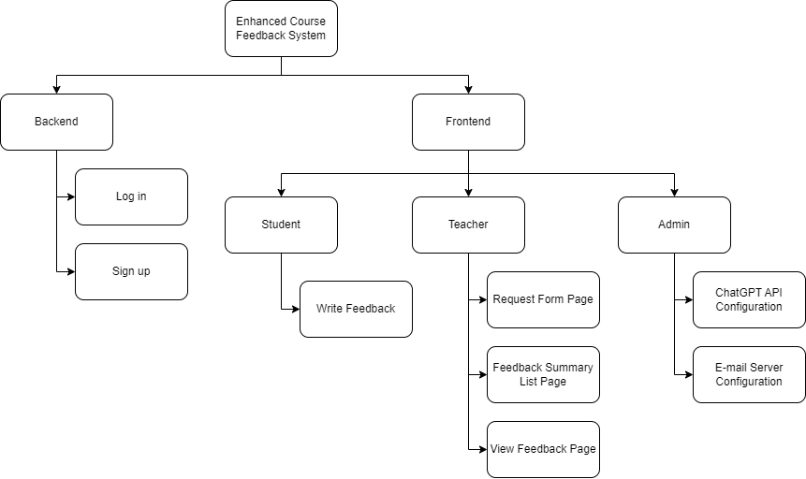

## System Operation

### 2.4.1 Activity Diagram

### 2.4.2 Use Case Diagram

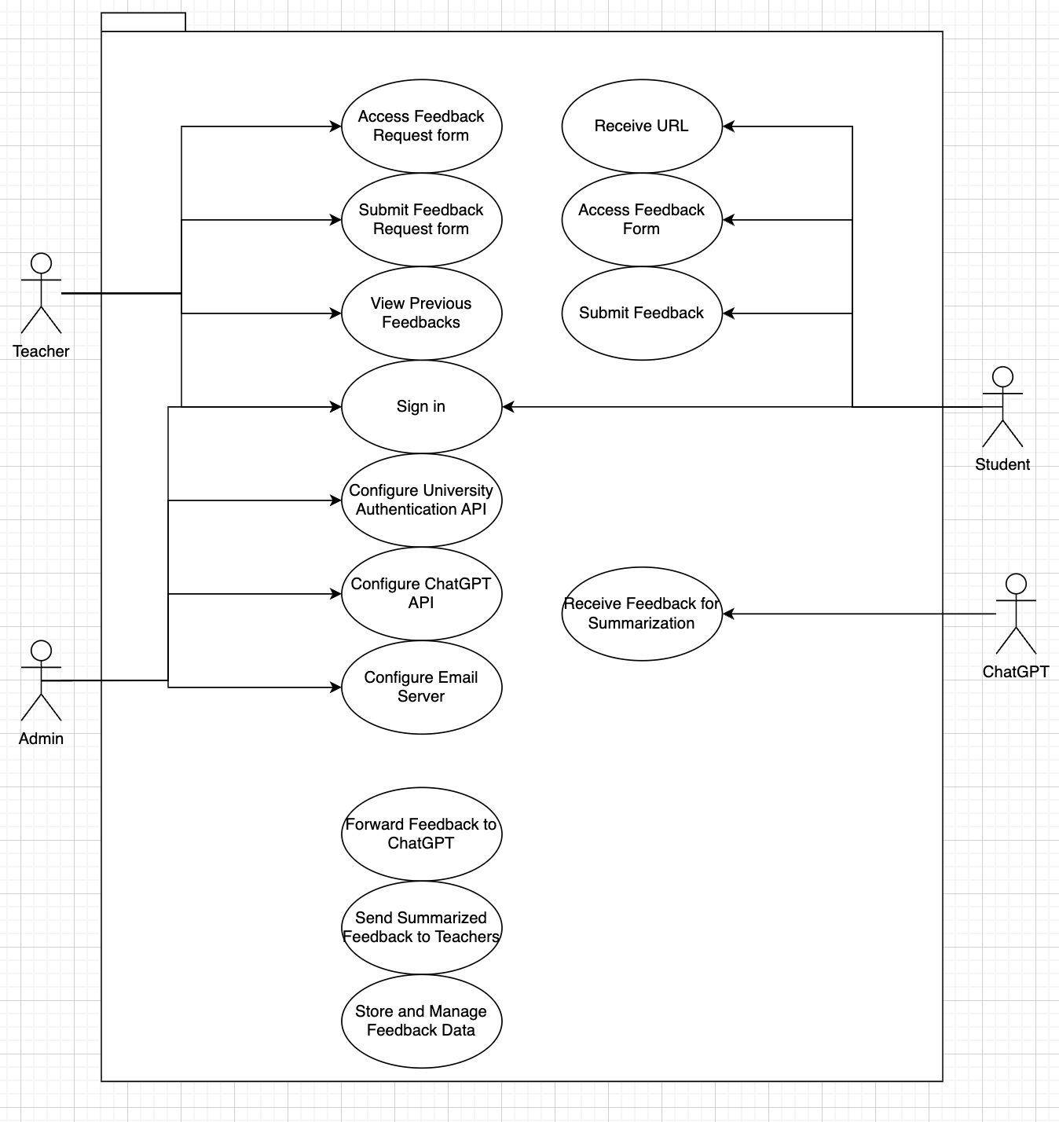

# UI Design

## 

## Sign Up Page

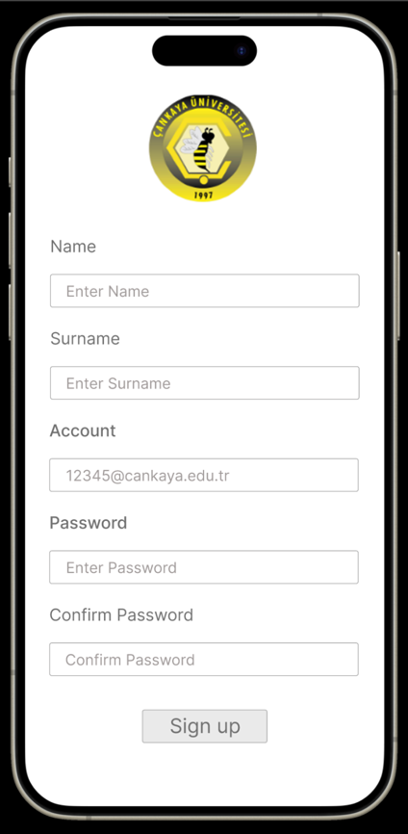

## Log in Page

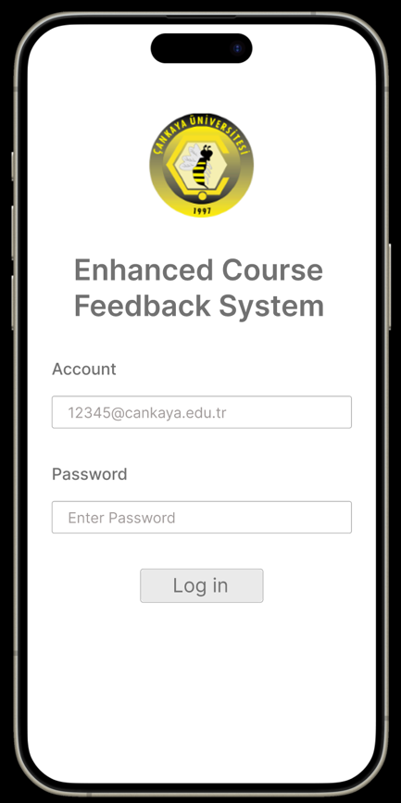

## 

## Feedback Request Form Page

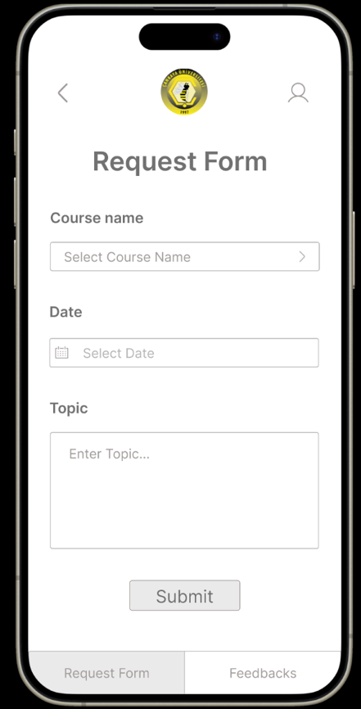 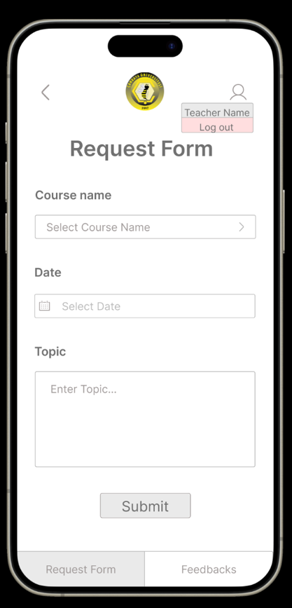

## Summarized Feedback List Page

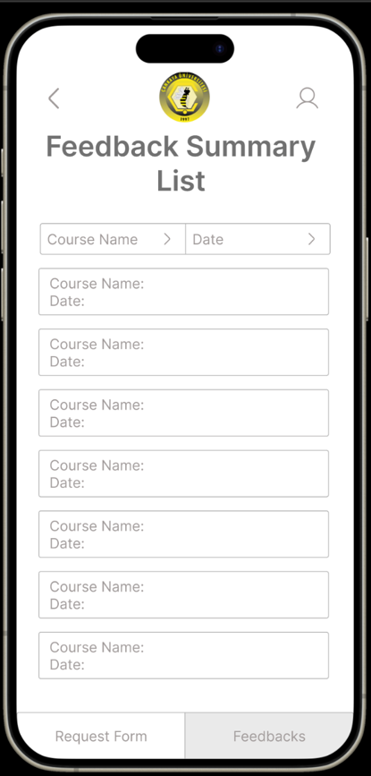 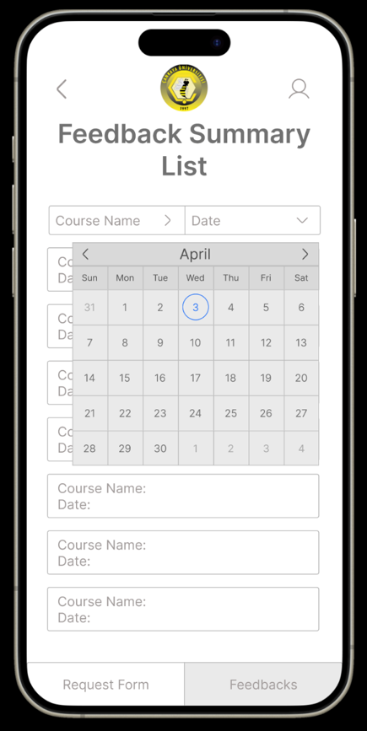 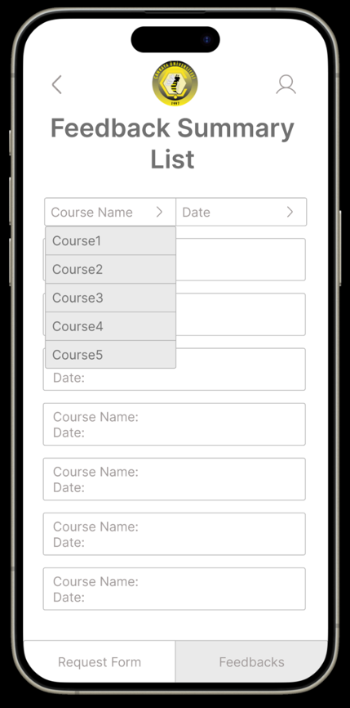

## View Feedback Page

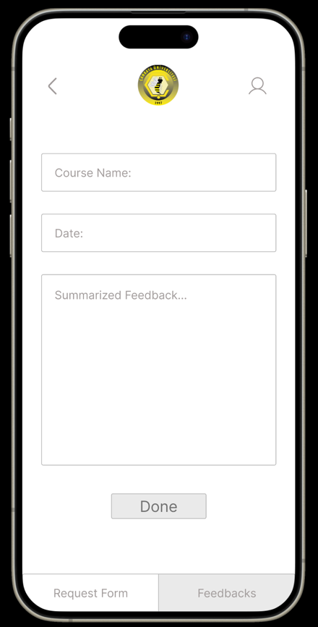

## 

## Student Feedback Form Page

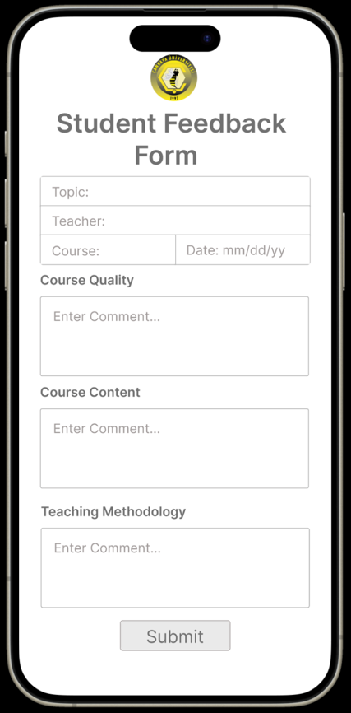

## GPT Config Page

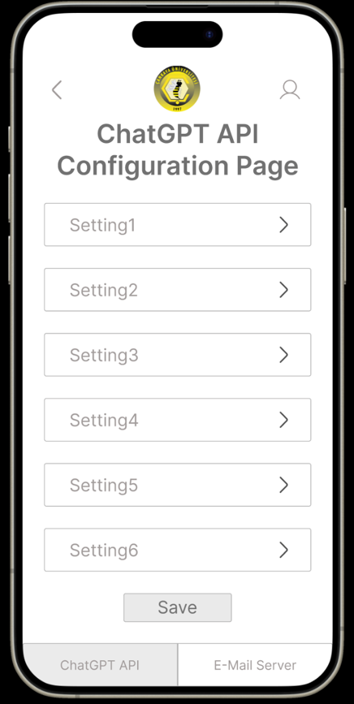

## 

## E-mail Server Config Page

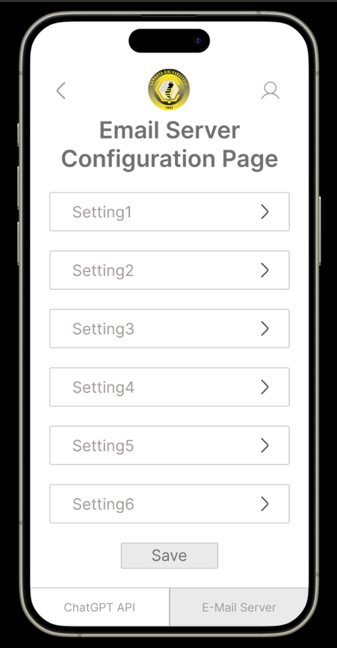

# 4. System Design

## 4.1 Sequence Diagram

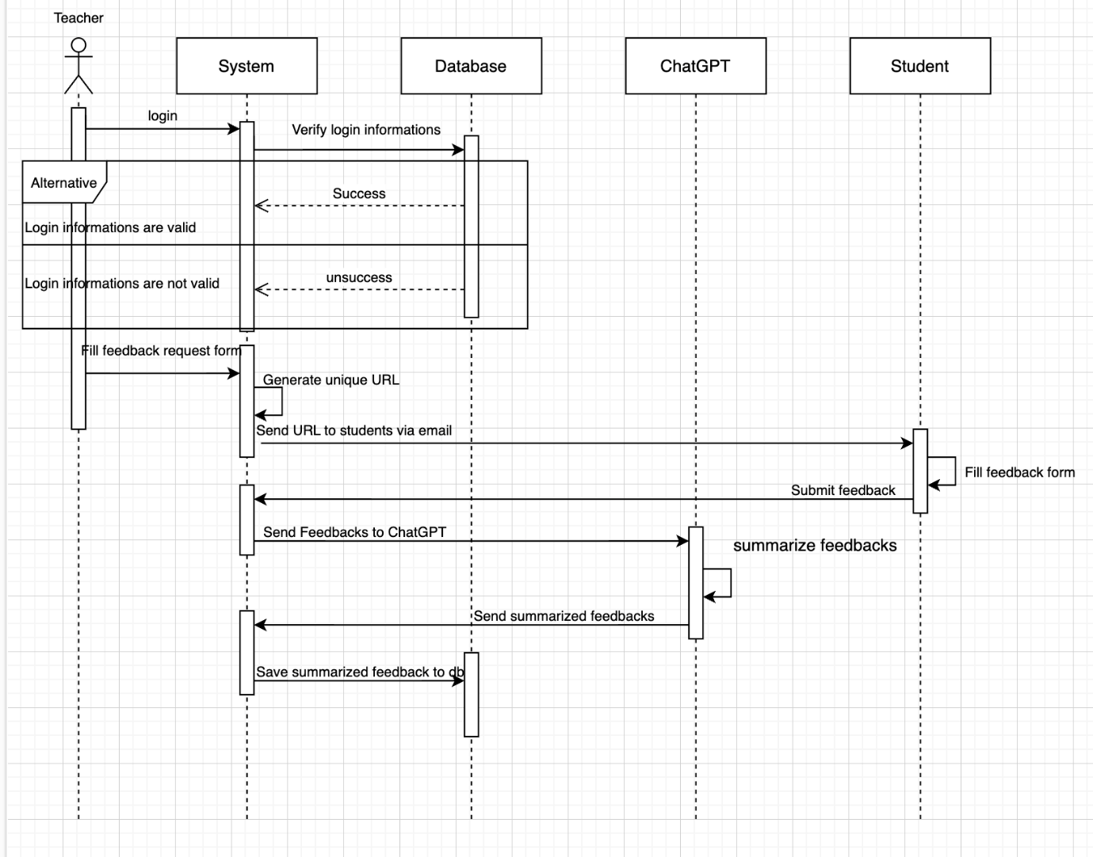

## 4.2 Data Model

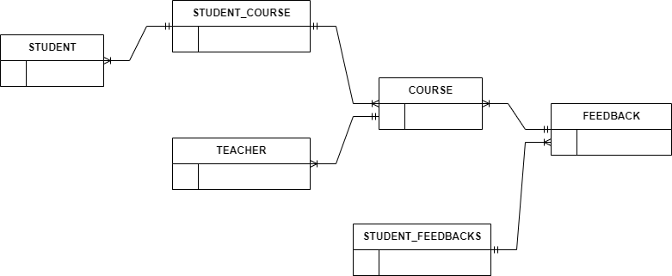

## 4.3 Design Elements

### 4.3.1 Student

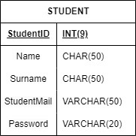

A student’s ID can be max 9 integers.

A student’s name can be max 50 characters.

A student’s surname can be max 50 characters.

A student’s mail can be max 50 characters, including “@” sign.

A student’s password can be max 20 characters.

### 4.3.2 Student Course

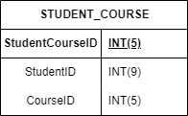

Student’s Course ID can be max 5 integers.

Course ID can be max 5 integers.

### 4.3.3 Teacher

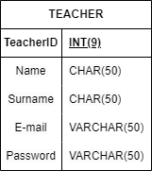

A teacher’s ID can be max 9 integers.

A teacher’s name can be max 50 characters.

A teacher’s surname can be max 50 characters.

A teacher’s e-mail can be max 50 characters.

A teacher’s password can be max 50 characters.

### 4.3.4 Course

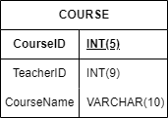

A course name can be max 10 characters.

### 4.3.5 Feedback

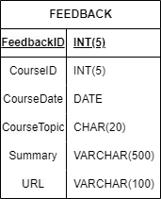

A feedback ID can be max 5 integers.

A course Date can only have DATE type.

A course topic can have 20 characters.

A summary can have 500 characters.

A URL can have 100 characters.

### 4.3.6 Student Feedback

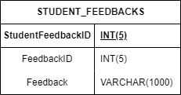

A student’s feedback ID can have 5 integers.

A feedback ID can have 5 integers.

A feedback can have 1000 characters.